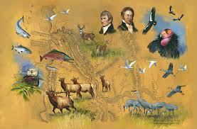
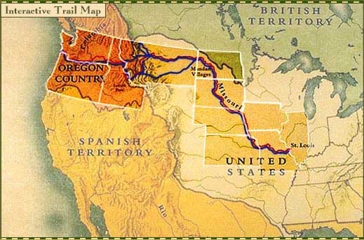
Lewis & Clark Exploration Card Game
Concentration Style

Easy: Match cards by category (Reptiles, Native American Handiwork, Landmarks, Carnivorous Animals, Fish, Hooved and Horned Animals, Land Birds, Water Birds, Plateau Indian Tribes, Plains Indian Tribes, Coastal Indian Tribes, Rodents, Plants)

Tell us about one item that you encountered during your expedition (game)?
- Category:
- Date:
- Location:
- Facts:

Medium: Match cards by Discovery Month and Year. (May 1804-September 1806)

Tell us about one item that you encountered during your expedition (game)?
- Category:
- Date:
- Location:
- Facts:

Difficult: Match cards by location (states) of discovery. (Illinois, Missouri, Kansas, Nebraska, Iowa, South Dakota, North Dakota, Montana, Idaho, Oregon, Washington) Don’t forget to use the map.

Tell us about one item that you encountered during your expedition (game)?
- Category:
- Date:
- Location:
- Facts:

